Gateway API Installation

1. Installation with Helm
Install with gateway-helm helm chart to install Envoy Gateway API in cluster.
helm install gateway-helm oci://docker.io/envoyproxy/gateway-helm --version 1.6.2 -n envoy-gateway
Verify installation
k get crds | grep gateway
k api-resources | grep gateway
kubectl get all -n envoy-gateway
# Check additional
k get gatewayclass
k get gateway
k get httproute
Note: Update externalTrafficPolicy By default external traffic policy in envoy proxy service is Local, so NodePort will not be reachable from other nodes, make it to Cluster and NodePort will be rechable from any node.
kubectl get svc -n envoy-gateway
kubectl edit svc envoy-envoy-gateway-web-gateway-d31157bf -n envoy-gateway
# Update to externalTrafficPolicy":"Cluster"

2. Create GatewayClass and Gateway
Create GatewayClass first
cat <<EOF | kubectl apply -f -
apiVersion: gateway.networking.k8s.io/v1
kind: GatewayClass
metadata:
name: envoy
spec:
controllerName: gateway.envoyproxy.io/gatewayclass-controller
description: "Envoy Gateway class"
EOF
Create gateway listening 80/443 ports with TLS Termination fonepay-cert
cat << EOF | k apply -f -
---
apiVersion: v1
data:
tls.crt: <base64 encoded cert>
tls.key: <base64 encoded key>
kind: Secret
metadata:
name: fonepay-cert
namespace: envoy-gateway
type: kubernetes.io/tls
EOF
gateway for prod
cat << EOF | kubectl apply -f -
apiVersion: gateway.networking.k8s.io/v1
kind: Gateway
metadata:
name: web-gateway
namespace: envoy-gateway
spec:
gatewayClassName: envoy
listeners:
- name: http
protocol: HTTP
port: 80
allowedRoutes:
namespaces:
from: All
- name: https
protocol: HTTPS
port: 443
hostname: "*.fonepay.com"
tls:
mode: Terminate
certificateRefs:
- name: fonepay-cert
namespace: envoy-gateway
allowedRoutes:
namespaces:
from: All # Same - to enable HttpRoute attachment from same NS only.
EOF
Similarly, multiple gateway can be created if required.

3. Verify installation
Check logs of envoy controller pod for any errors:
kubectl logs -f deploy/envoy-gateway -n envoy-gateway
Check envoy-proxy pods: 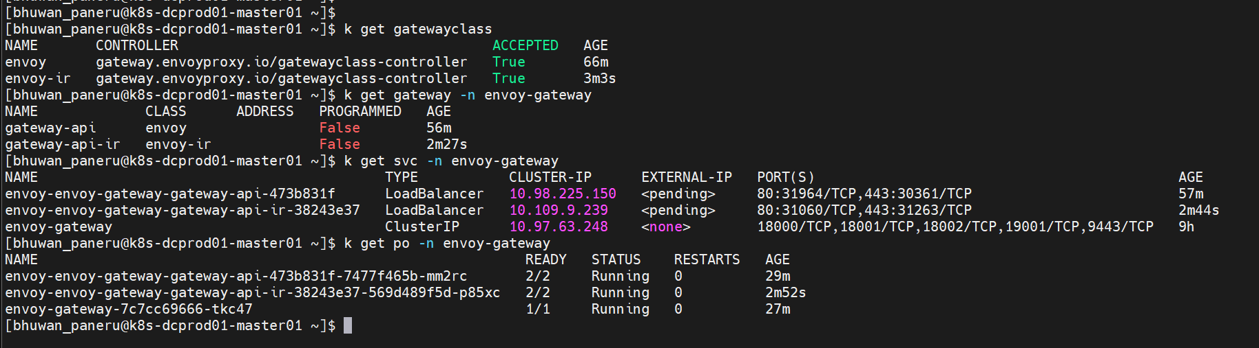
k get pods -n envoy-gateway
k get svc -n envoy-gateway
# envoy-envoy-gateway-gateway-api-473b831f-7477f465b-mm2rc <-- envoy proxy pod
# envoy-gateway-656d67f79d-v5hhm <-- envoy gateway controller pod

4. Allowing required port in firewall
envoy proxy communications:
[ envoy-proxy POD ] ─── xDS gRPC :18000 ───► [ envoy-gateway POD ]
[ kube-apiserver ] ─── HTTPS :9443 ───► [ envoy-gateway POD ]
[ prometheus ] ─── HTTP :19001 ───► [ envoy-gateway POD ]
Only envoy proxy NodePorts are required to open in firewall
sudo firewall-cmd --add-port=30000-32767/tcp --permanent
sudo firewall-cmd --reload
sudo firewall-cmd --permanent --add-source=10.31.214.0/24
sudo firewall-cmd --reload

5. Test using a simple nginx pod and HTTPRoute
Create nginx pod and expose pod to service:
kubectl run po nginx --image nginx
kubectl expose po nginx --port=80
Create HTTPRoute for nginx pod:
cat << EOF | kubectl apply -f -
apiVersion: gateway.networking.k8s.io/v1
kind: HTTPRoute
metadata:
name: nginx-route
namespace: default
spec:
parentRefs:
- name: web-gateway
namespace: envoy-gateway
hostnames:
- "nginx.fonepay.com"
rules:
- matches:
- path:
type: PathPrefix
value: /
backendRefs:
- name: nginx
namespace: default
kind: Service
port: 80
weight: 1
EOF
Test using curl command:
# telnet 10.31.214.110 <nodeport>
# Test connectivity with http and https
curl -vk --resolve nginx.fonepay.com:31444:10.31.214.110 http://nginx.fonepay.com:31444
curl -vk --resolve nginx.fonepay.com:30361:10.31.214.110 https://nginx.fonepay.com:30361

